Watch battery fitting – Ballymena
Robert Adair Jewellers offer a specialist watch battery replacement service for quality watches.
Robert Adair Jewellers a Ballymena based business for over 55 years offers a specialist watch battery fitting service. Our service includes:-
Batteries fitted by Swiss trained watchmaker
One hour service
Only quality Swiss made Renata batteries used
All seals visually checked
1 year guarantee on all battery replacements
Contacts cleaned and adjusted as necessary
Watch pressure testing available for small extra charge
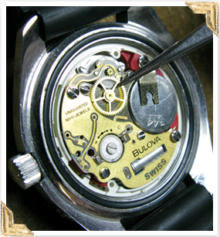
Batteries fitted to quality Swiss watches such as Omega --

Why pay up to £80.00 to send your watch back to the manufactuer when a quality battery fitting service is available locally.

For more information watch waterproof testing or battery fitting contact Stuart Adair:-
Robert Adair Jewellers 47/51 Mill Street, Ballymena.
Tel:- 028 2565 6896
info@robertadairjewellers.com

